

"Empowering your digital world"

Version: 2.0

Website: https://hrm-odell.odelltech.com/

Last Update: May 1, 2023

### Presented by Mashuqur Rahman Tanmoy

|  |  |
| --- | --- |
|  | Documentation Of Attendance Report  An attendance report is a document that provides information on the attendance of individuals or groups within an organization or institution. It typically includes data on the number of days or hours worked, the number of days or hours absent, and any other relevant attendance-related information. |

|  |  |  |  |  |
| --- | --- | --- | --- | --- |
| Item # | Item name | Description |  | Page no |
| 1 | Absent Report | An absent report is a document that provides information on the individuals or groups who were absent from work, school, or an event on a particular day or during a specific period. It usually includes the names of the absent individuals, the reason for their absence, the date or dates of their absence, and any other relevant information. |  | 0 |
| 2 | Attendance Summary Report | An attendance summary report is a document that provides an overview of attendance data over a specific period of time, such as a week, month, or quarter. It typically includes information on the total number of days or hours worked, the total number of days or hours absent, and any other relevant attendance-related information. |  | 0 |
| 3 | Daily attendance | Daily attendance refers to the recording of the presence or absence of individuals on a daily basis. It is the process of tracking and documenting the attendance of employees, students, or participants in an event or activity each day. Daily attendance is usually recorded by taking note of who is present and who is absent, along with any relevant reasons for absence. |  | 0 |
| 4 | Working hour control report | A working hour control report is a document that provides information on the hours worked by employees during a specific period of time. This report typically includes data on the number of hours worked by each employee, as well as any overtime, vacation time, or sick time taken.  Working hour control reports are often used by employers, human resources departments, and payroll departments to track employee hours and ensure compliance with labor laws and company policies. By analyzing working hour control reports, organizations can identify any discrepancies or issues with employee hours, and take steps to address them. This might include adjusting employee schedules, providing additional training on time and attendance policies, or implementing new time and attendance systems to improve accuracy and efficiency. |  |  |
| 5 | Attendance General Report | An attendance general report is a document that provides an overview of attendance data for a specific period of time, such as a week, month, or year. It typically includes information on the total number of days or hours worked, the total number of days or hours absent, and any other relevant attendance-related information. |  |  |
| 6 | Multiple-Employee Monthly Attendance Report | A multiple-employee monthly attendance report is a document that provides an overview of the attendance records of multiple employees over the course of a month. It typically includes information on the number of days or hours each employee worked, the number of days or hours each employee was absent, and any other relevant attendance-related information. |  |  |
| 7 | OT (overtime) holder time-wise report is | An OT (overtime) holder time-wise report is a document that provides information on the overtime hours worked by employees over a specific period of time, broken down by time intervals (such as hourly, daily, or weekly). It typically includes data on the total number of overtime hours worked by each employee, as well as the dates and times of those overtime hours. OT holder time wise reports are often used by employers and payroll departments to track overtime hours worked by employees and ensure compliance with labor laws and company policies regarding overtime. By analyzing OT holder time wise reports, organizations can identify patterns and trends in overtime hours worked, and take steps to manage overtime costs and ensure that employees are compensated fairly for their work. |  |  |
| 8 | OT (overtime) summary report | An OT (overtime) summary report is a document that provides an overview of the overtime hours worked by employees over a specific period of time, such as a week, month, or year. It typically includes data on the total number of overtime hours worked by each employee, as well as any other relevant information such as the reason for the overtime work and the compensation earned. |  |  |
| 9 | single-employee monthly | A single-employee monthly attendance report is a document that provides an overview of the attendance record of a single employee over the course of a month. It typically includes information on the number of days or hours the employee worked, the number of days or hours the employee was absent, and any other relevant attendance-related information. |  |  |
| 10 | Today's absent report | Today's absent report is a document that provides information on the employees who were absent from work on a particular day. It typically includes the names of the absent employees, their department or job title, the reason for their absence (if known), and any other relevant information. |  |  |
| 11 | Today's attendance summary report | Today's attendance summary report is a document that provides an overview of the attendance record of employees on a particular day. It typically includes information on the number of employees present, the number of employees absent, and any other relevant attendance-related information. |  |  |
| 12 | Today's present report | Today's present report is a document that provides information on the employees who were present at work on a particular day. It typically includes the names of the present employees, their department or job title, and any other relevant information. |  |  |

# Absent Report

By following these steps, you can easily generate an absent report from the attendance report, providing you with valuable information on employee attendance and helping you identify patterns of absenteeism.

Try It: Please login here: <https://hrm-odell.odelltech.com/> with your id & pass  
 message us: Please E-mail us: [ctrl+ click here to message us](mailto:support.odelltech@odell.com.bd?subject=Information%20)

1. Click on the "Report" option in the menu.
2. Select the "Attendance Report" from the list of available reports.
3. Filter the report by the date range and employee criteria as needed.
4. Identify the employees who were absent during the selected period.
5. Click on the "Absent Report" option or button within the attendance report.
6. The system will generate the absent report, which will provide details of the employees who were absent during the selected period.

[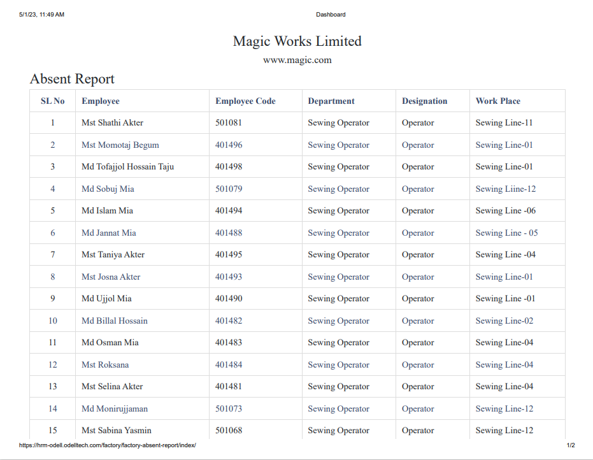](Pdf%20Report%20Link/1%20Absent%20Report.pdf)

"If you would like to learn more about this feature and print out a copy of the photo shown, please click here for a PDF version.":

[ Ctrl+Click Here with pressing control button or Ctrl+Click the above photo](Pdf%20Report%20Link/1%20Absent%20Report.pdf)

# Attendance summary Report

By following these steps, you can easily generate an attendance summary report from the attendance report, providing you with a concise overview of employee attendance and helping you identify patterns of attendance.

Try It: Please login here: <https://hrm-odell.odelltech.com/> with your id & pass  
 message us: Please E-mail us: [ctrl+ click here to message us](mailto:support.odelltech@odell.com.bd?subject=Information%20)

1. Click on the "Report" option in the menu.
2. Select the "Attendance Summary Report" from the list of available reports.
3. Filter the report by the date range and employee criteria as needed.
4. Review the attendance report to ensure it accurately reflects employee attendance during the selected period.
5. Click on the "Attendance Summary Report" option or button within the attendance report.
6. The system will generate the attendance summary report, which will provide a summary of employee attendance for the selected period.

[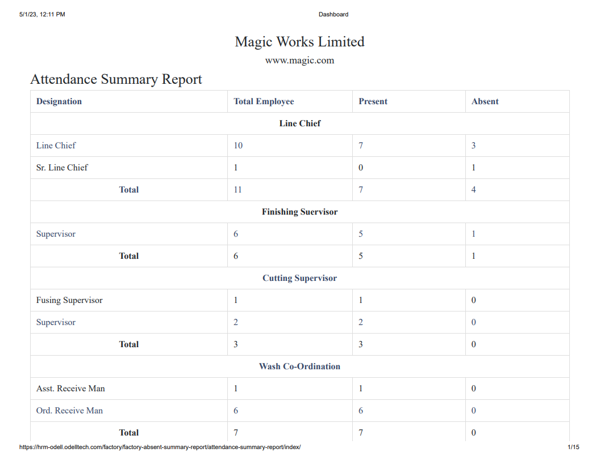](Pdf%20Report%20Link/2%20Attendance%20Summary%20Report.pdf)

"If you would like to learn more about this feature and print out a copy of the photo shown, please click here for a PDF version.":

[ Ctrl+Click Here with pressing control button or Ctrl+Click the above photo](Pdf%20Report%20Link/2%20Attendance%20Summary%20Report.pdf)